Technical Note

MixtureAce Bioinformatic Trim Configurations
November 4, 2024

Background
PCR-MPS methods are analytical chemistry techniques for determining the sequence of specifically targeted genomic regions. The PCR stage generates PCR amplicon molecules that include DNA copies with the PCR primers on the outside edges of the targeted regions. Synthetic non-human oligonucleotide sequences used in the sequencing process are ligated to the outer (5´) edges of the PCR primers. Thus, the resulting PCR amplicons consist of a targeted genomic extent, PCR primers, and oligonucleotide sequencing tags.
When PCR amplicon molecules are sequenced, the resulting sequencing reads are text-based representations of the amplicon nucleotide sequence including the target region, the PCR primers, and the oligonucleotide tags. Sequencer control software optionally bioinformatically trims away oligonucleotide sequences outside the primers, and trimmed sequencing reads are written to FASTQ files (Figure 1).

Edge Locations
Identifying the edges between the various segments of sequencing reads is key to bioinformatic trimming. The edges of the STR locus can be reliably identified only by the complex sequence outside the STR locus. The sequence of the STR locus itself is too unpredictable to tell where it starts and ends. This can be thought of as an “outside-in” definition of an STR locus where the STR locus is defined as the segment inside two reliable anchor sequences. The PCR primer sequences are reliably identifiable, since they are designed to be unique within the human genome. About 12 or more nucleotides of the inside (3´) ends of the primers are reliable landmarks for finding the edge of the targeted genomic region. This region is sometimes called the examined region, because it is the sequence-based allele identified during forensic examination.

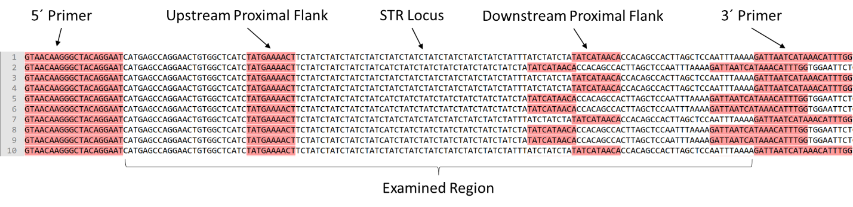
Figure 1. Illustration of sequencing reads targeting the D2S441 locus, where two alleles are present whose bracketed representations are: [TCTA]12, and [TCTA]4 TCA [TCTA]7.

MixtureAce Bioinformatic Trimming Protocols
The molecular extents reported by MixtureAce can be varied by changing the bioinformatic trim positions (Table 1). Different trim protocols generate molecular extents that differ by SID label and population frequency (1). Differences in population frequency can generate differences in levels of statistical support for matching genotypes ().

Table 1. Bioinformatic trimming protocols implemented in MixtureAce.
Protocol Name | Letter Designation | Region Reported | Why
STR Only | A | The STR locus and optionally some nearby flank | Bracketed STR sequences are useful for diagnosing stutter.
Fixed Trim | B | The examined region when the inside (3´) positions of the PCR primers are unknown | Some kit vendors do not reveal their primer extents.
Examined Region | C | The sequence-based allele which is defined as the region inside the PCR primers | This is the sequence-based allele.
Intersection | D | The overlap of the molecular extent of kit examined regions and regions represented in the relevant allele frequency database. | When kit and database extents are different, the intersection frequencies are more favorable to the defendant than kit examined region frequencies (1).
NIST Minimum Range | E | A region defined by NIST that includes the STR locus and minimal adjacent flank. | Designed by NIST to facilitate cross-kit comparisons of sequence-based alleles (2).

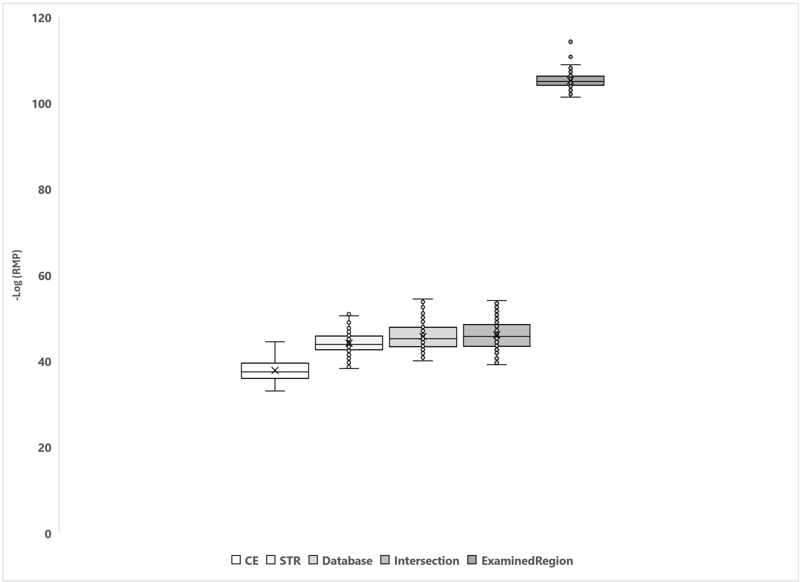
Figure 2. Box plot of negative log random match probabilities for 100 randomly generated profiles of 27 autosomal STR markers in the OmniSTR kit. Plots show distributions of RMPs for five different treatments of the same data. The relevant allele frequency database is the sequence-based NIST 1036.

Customization of Bioinformatic Trimming
Bioinformatic trimming positions are user-customizable in MixtureAce. Five standard trim protocols are available (Table 1), but users can create their own custom protocols. Trimming to the intersection of kit and database molecular extents can have a profound impact on strengths of evidence (Figure 2). Kit-database intersections depend upon the relevant kit and database. The nine possible Intersection patterns are illustrated in Table 2 for the OmniSTR kit and the NIST 1036 sequence-based allele frequency database (3, 4).

Table 2. Illustration of intersections between the OmniSTR kit and the NIST 1036 sequence-based allele frequency database.

Literature Cited

1. Young B, Marciano M, Crenshaw K, Duncan G, Armogida L, McCord B. Match statistics for sequence-based alleles in profiles from forensic PCR-mps kits. Electrophoresis. 2021;42(6):756-65.
2. Gettings KB, Bodner M, Borsuk L, King J, Ballard D. Recommendations of the DNA Commission of the International Society for Forensic Genetics (ISFG) on short tandem repeat sequence nomenclature. Forensic Sci Int. 2024;68.
3. Borsuk LA, Gettings KB, Steffen CR, Kiesler KM, Vallone PM. Sequence-based US population data for the SE33 locus. Electrophoresis. 2018;39(21):2694-701.
4. Gettings KB, Borsuk LA, Steffen CR, Kiesler KM, Vallone PM. Sequence-based U.S. population data for 27 autosomal STR loci. Forensic Sci Int Genet. 2018;37:106-15.

